 

# Wisconsin Home Energy Assistance Programs Reference Guide

## WHEAP

* [**Wisconsin Home Energy Assistance Program (WHEAP) Website**](https://energyandhousing.wi.gov/Pages/AgencyResources/energy-assistance.aspx)  
  Brochures in English, Spanish, and Hmong are available on this page:
  + **Energy Assistance Brochure:** [**English (pdf)**](https://energyandhousing.wi.gov/PublishingImages/Pages/AgencyResources/energy-assistance/(English).pdf) | [**Spanish (pdf)**](https://energyandhousing.wi.gov/PublishingImages/Pages/AgencyResources/energy-assistance/(Spanish).pdf) | [**Hmong (pdf)**](https://energyandhousing.wi.gov/PublishingImages/Pages/AgencyResources/energy-assistance/(Hmong).pdf)
* [**WHEAP Program Income Limits**](https://energyandhousing.wi.gov/Pages/AgencyResources/energy-assistance.aspx)
* [**Wisconsin Home Energy Assistance Application Checklist**](https://energyandhousing.wi.gov/Documents/HEPlusSharedFiles/App%20Checklist_English.pdf)
* [**Wisconsin County Map of Resources and Assistance**](https://energyandhousing.wi.gov/Pages/Home.aspx)

[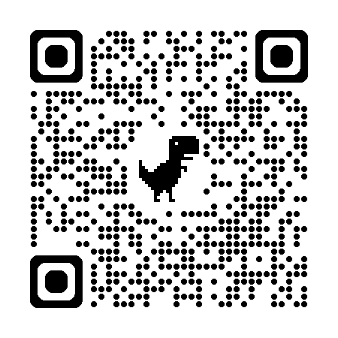](http://www.energyandhousing.wi.gov)

## Weatherization

* [**PY 2024 Wisconsin Weatherization Assistance Program Providers**](https://energyandhousing.wi.gov/Documents/Weatherization/WX%20Providers%20by%20Agency%20Map%20PY24_Rev%204-24.pdf)
* [**PY2024 - 2025 Weatherization Program Manual**](https://energyandhousing.wi.gov/Documents/Weatherization/PY%202024-25%20Wx%20Program%20Manual%20Redline%20(1).pdf)
* [**Weatherization Assistance Program Fact Sheet**](https://energyandhousing.wi.gov/Documents/Weatherization/weatherization-assistance-program-fact-sheet.pdf)

## HE+ HVAC and Water Conservation Programs

* [**HE+ HVAC Program Services - HVAC and Water Conservation**](https://energyandhousing.wi.gov/Pages/AgencyResources/furnace.aspx)

## Miscellaneous

* [**Energy Saving Tips (PDF)**](https://ci.hartford.wi.us/DocumentCenter/View/1106/Energy-Saving-Tips-PDF)
* [**Household Housing Guide (PDF)**](https://ci.hartford.wi.us/DocumentCenter/View/1105/Household-Housing-Guide-PDF)

*The development of this resource was funded by the Wisconsin Department of Health Services**as part of the* ***Wisconsin Disability Benefits Network*** *Initial Training for Work Incentive Benefit Specialists.*